GUIDELINES FOR EXTENDED ABSTRACT PREPARATION & SAMPLE TEMPLATE

- Extended Abstracts are strictly limited to 6 pages (A4 size) including figures /tables / graphics.
- Extended Abstracts must be submitted in English language only.
- Use Arial font only.
- An Abstract of around 200 words is a must for each Extended Abstract.
- Lines must be single-spaced (plus additional space between paragraphs)
- Align text to both left and right margins (justified text). Do not use columns.
- The Title of the paper should be in bold and in sentence case (Font size=14 point)
- Main Text: All headings 12 point bold and rest of the text 10 points normal.
- The file should be in MS Word format and size should not be more than 20 MB.
- Company logo should be avoided.
- Do not write the Names and details of the author(s) in the uploaded extended abstract.
- Tables and figures must be included in the same file.
- Extended Abstract should be uploaded using ‘Document Upload’ facility provided in the GeoPapers Portal only, no other mode will be entertained.

SAMPLE PAPER (Template) is enclosed below for reference

SSAMPLE PAPER
( NOT TO BE USED FOR ANY OTHER PURPOSE)
Geomechanical and rock properties analysis: an implication for reservoir development in XYZ Basin, India

Abstract

Comprehensive geomechanical parameters such as in-situ stress, pore pressure, fracture pressure along with rock properties are very much important to understand the behaviour the subsurface reservoirs during the drilling of wellbore, reservoir modelling, well stimulation and production strategies. Two wells KA and KK located at oil/gas fields of West and Z sub-basins have been used to compute those parameters. The vertical stress gradient varies from 21.80 to 22.85 MPa/km for the two wells. The gas sands are identified in high pressured shale and are separated from non-reservoir lithology using Lamda-Mu-Rho (LMR) technique.

Introduction

The Petroleum industry nowadays has focused its attention on geomechanics since this is the ﬁeld of science that contributes to the understanding and problem - solving regarding reservoir stability. The knowledge of the orientation and magnitude of the principal stresses along with pore pressure and fracture pressure is essential in any comprehensive geomechanical model. Borehole breakouts and drilling induced fractures have long been recognized as stress-induced features because we can use information on their azimuth to determine orientations of in situ principal stresses. The variation in the local stress in any producing basin is affecting the exploration strategy, development plan and reservoir recovery. Fracture orientation, well stability, horizontal well orientation and permeability anisotropy are strongly affected by the variation in the local stress field. A thorough understanding of in situ stress conditions and rock properties, such as compressive strength, elastic moduli and anisotropy are required to optimize the wellbore design. In the hydrocarbon producing sedimentary basin, these rock properties can be derived from the P and S waves of modern sonic tools. The determination of mechanical properties of rock is important for a variety of reservoir engineering purposes like hydraulic fracturing, estimation of removable reserves, prediction of wellbore stability and subsidence.
The XYZ (XYZ) basin is a pericratonic basin situated on the passive Eastern Continental Margin of India (ECMI). XYZ basin encompasses large areas both onland and offshore including those located in deep waters. The basin itself came into existence following rifting along ECMI craton during early Mesozoic. Both the onland part of the basin and its off shore host a large number of structural traps that have been mapped and a large number of them established through drilling (Rao, 2001).The basin was created as a result of tensional basement tectonics and is characterized by ENE-WSW to NE-SW trending horsts and sub-basins/grabens overlying a rifted basement structure. XYZ basin is subdivided into three sub-basins namely; X, Y and Z which are separated by A and A horsts respectively (Figure 1) (Sastri et al., 1973 and 1981). The location of two wells is shown in the figure 1.
In this paper we focus on (a) determination of the in-situ stress field, pore pressure and fracture initiation pressure of two wells located in the XYZ (XYZ) basin, (b) computation of mechanical properties such as Young’s modulus, Poisson’s ratio from logs of compressional/shear wave velocities (Vp/Vs) for these well and finally (c) identification of sand and shale from two wells using LMR technique.

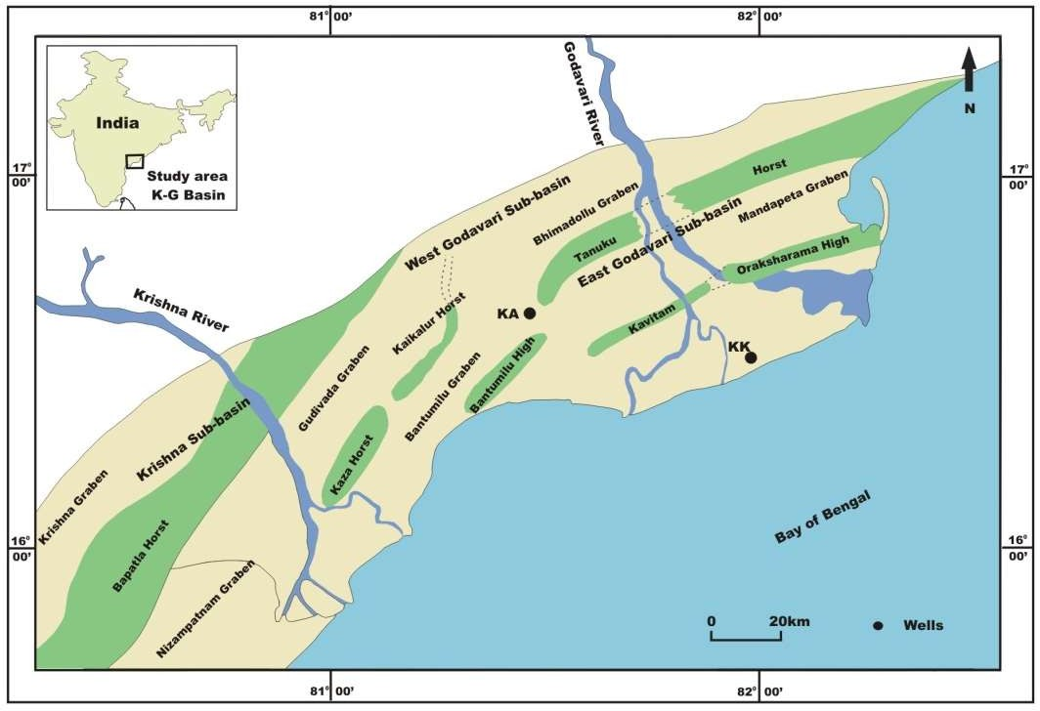

Figure 1: Display the XYZ basin with the location of two wells, KA and KK under study.

Geomechanical Parameters: in-situ stress, pore pressure and fracture pressure
It is essential to determine the magnitude of principal stresses. These principal stresses are the vertical stress and the maximum and minimum horizontal stresses. Using the magnitude of vertical stress data, pore pressure (PP) is computed from Eaton’s sonic (Eaton, 1972). Fracture pressures (FP) have been obtained (MNO and IJK, 2014) using the magnitude of vertical and minimum horizontal stress from Matthews–Kelly’s equations (Matthews and Kell, 1967).

Pore pressure as derived from Eaton’s (Eaton1972) sonic equation:

PP = SV – (SV – Ph) (∆tpn/∆tp)³ (1)

where, = hydrostatic pressure, ∆tpn = compressional wave travel time in low permeable zone
calculated from normal compaction trend for the six wells of XYZ basin (MNO and IJK, 2014), ∆tp = observed compressional wave travel time. Hydrostatic pressure gradient is considered as 10 MPa/km for the six wells in this basin. PP obtained from equation (1) is further calibrated by the Repeat Formation Tester (RFT) data for the two well (Figure 2).

The fracture pressure determined from Matthews–Kelly’s equation (Matthews and Kelly 1967) as FP = Ki x (Sv – PP) +PP (2)
Ki= matrix stress coefficient = Sh/SV where Sh= minimum horizontal stress calculated from the following equation (Engelder, 1994, MNO and IJK, 2014)

Sh = PP + v * (Sv –PP)/(1- v) (3)

where v is Poisson’s ratio of the rock in the XYZ basin ranging from 0.24 to 0.28 (IJK and Mukhopadhyay, 2002). The magnitude of Sh is validated by the closure stress data measured from Leak-off Test (LOT) at selected depths for these wells (Figure 2). The variation of in-situ stress, pore pressure and fracture pressure with depth for two wells are illustrated in figure 2.

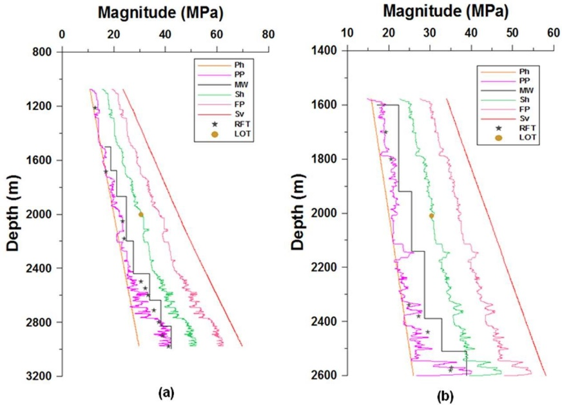

Figure 2: Showing the in-situ stresses, pore pressure, fracture pressure for (a) well KA and (b) well KK respectively.

There is a departure of PP from hydrostatic pressure profile showing the excess of normal hydrostatic pressure gradient. The top of overpressure zones (OPZs) are indentified at depths 2280m and 2324m from wells KA and KK respectively. The pore pressure and fracture pressure gradient in OPZ are
12.30 MPa/km and 19.78 MPa/km for well KA and 12.32 MPa/km and 19.00 MPa/km for well KK. This OPZ is encountering Raghavapuram Shale of Early Cretaceous in well KA as well as Vadaparru Shale of Late Eocene-Miocene in well KK respectively. Overpressure in the Shale formation controls hydrocarbon accumulation, because of its strong sealing capacity (Li et al., 2008). The overpressure existing in the Shale formation can drive hydrocarbon migration from the source rock to the traps (Tang and Lerche, 1993; Hao et al., 2002). To maintain the stability of a well in the XYZ basin, proper mud weight (MW) can be estimated from PP studies. Selection of MW for pressure control requires knowledge of PP and FP gradients. So the mud window has to be selected between this pore pressure and fracture pressure limit during the well drilling. The pore pressure values are also useful for basin modelling and reservoir production.

Estimation of Rock properties

Mechanical properties of rocks vary significantly between reservoirs and within a reservoir due to the wide variety of material composition and intrinsic anisotropy exhibited by shales. Heterogeneous rock properties in terms of layering and complex infrastructure of fault zones are typical phenomena in sedimentary basins. Estimation of rock mechanical properties in the industry is associated with measurement of compressional wave velocity (VP) and shear wave velocity (VS) at laboratory and from well logs (Boonen, 2003). The VP/Vs and density log data are available for selected depth intervals from two wells for computation of Poisson’s ratio and Young’s modulus.

Poisson’s ratio (v) as

ν = [0.5(Vp/Vs)2 – 1]/[ (Vp/Vs)2 – 1] (4)

Young’s modulus (Y) as

Y = 2μ(1 + ν) (5) , where μ is modulus of rigidity

Figure 3 illustrates the variation of Young’s modulus and Poisson’s ratio with depth for these two wells. High Poisson’s ratio of about 0.4 indicates the unconsolidated low permeability sediments. This is due to the overpressured Shale as observed in these well (MNO and IJK, 2014).

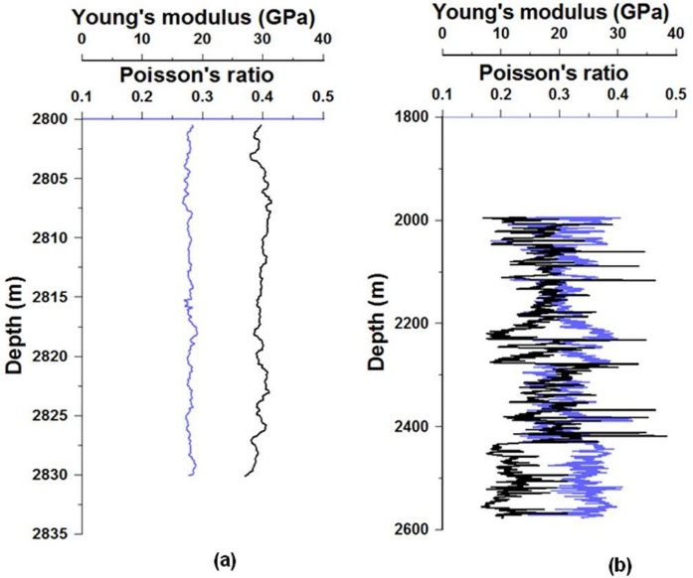

Figure 3: Variation of rock properties with depth for (a) well KA and (b) well KK respectively.

Reservoir implication:

Goodway (1997) proposed methodology to extract rock properties. He promoted the usage of relationship between lame’ s parameters Lamda (λ) (incompressibility), Mu (μ) (rigidity) and Rho (ρ) (density) to separate lithologies and identify gas sands. These parameters are very useful for lithology discrimination and are related to the rock matrix. Quartz is the dominant mineral in the sand matrix, therefore sandstone usually associated with high rigidity than shale (Goodway et al. 1997). The most interesting result from this principle is that sand matrix has higher value of Mu-Rho (μρ) than the overlying shale. Lambda-Rho (λρ) or incompressibility is a very useful parameter to distinguish fluid content which is subjected to pore fluid. A number of studies have indicated that the hydrocarbon bearing sand is less dense than water bearing sand and also are more compressive than wet sandstone. As a result, in sand reservoir the Lambda-Rho (λρ) log shows low incompressibility values. Regarding the rigidity and incompressibility, gas sand reservoir should correspond to the low λ incompressibility (<20 GPa) combined with high rigidity μ (>15 GPa) of sand grain. We should consider the fact that neither 𝜆 nor 𝜇 are powerful and accurate indicator individually, however the combination of 𝜆𝜌 and 𝜇𝜌 are generally used for reservoir fluid identification. Equations 6 and 7 have been used to compute these parameters.
Z²s = (ρVs)² = µρ (6)

Z²p = (ρVp)² = (λ + 2µ)ρ
λρ = Z²p - 2Z²s (7)

where, P-Impedance (Zp) = 𝜌𝑉P and S-Impedance (Zs) = 𝜌𝑉S
The Vp/Vs data is available in depth interval 2800-2830m and gas bearing sand isolated from shale lithology shown in figure 4a. This shale formation is characterised by high pore pressure gradient. The gas sands have been separated from KK well within depth interval 2010-2538m. The other lithology such as shaly sand, shale and clastic-carbonate are also identified shown in figure 4b. The analysis of logs for the selected depth interval for two wells and the 𝜆𝜇𝜌 (LMR) plot identifies the reservoirs within overpressured shale. The conventional log such as: neutron-density cross-over indicates the gas bearing sand units within 2810-2930m for well KA (Figure 4c). The geomechanical and rock properties will be helpful in identifying fluid migration path, conditioning wellbore stability for reservoir development.

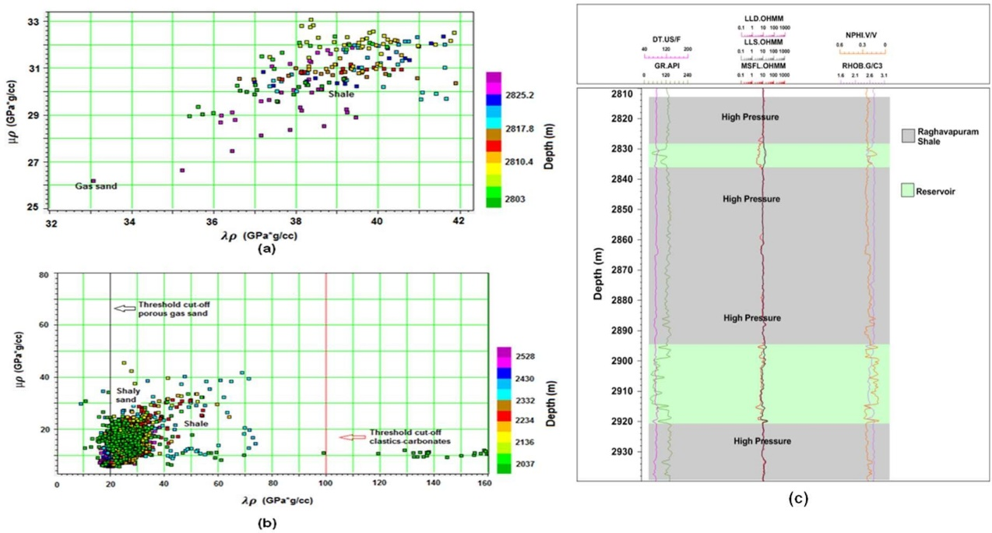

Figure 4: LMR plot for (a) well KA and (b) well KK respectively. Gas sands are separated from the non reservoir litho unit. The shaly sand, shale are also identifiable from these plot (c) reservoir units in overpressured shale of KA well.

Magnitudes and orientation of in-situ stress in reservoirs may be used for several aspects of hydrocarbon exploration like; well design, well location, production optimization, designing fracture stimulation treatments, understanding and controlling casing deformations.

Conclusions

In-situ stress stress, pore pressure and fracture pressure have been estimated from two wells. The over pressure zones are encountered at depth 2280 m in KA well and 2324 m in KK well respectively. Young modulus and Poisson’s ratio have been computed for the selected depth interval of the same wells. The gas sands are identified from the LMR cross-plot technique. Due to the high pressure sealing shale, hydrocarbon migration to reservoir accounts for suitable study of reservoir development.

Acknowledgement

Authors are very much thankful to PQR Dehradun for providing the data and geologic information. Authors acknowledge the financial support from the Ministry of Earth Science through the R&D project MoES /P.O./(Seismo)/1(138) 2011 dated 9.11.12.

References

Boonen, P., 2003, Advantages and Challenges of Using Logging-While-Drilling Data in Rock Mechanical Log Analysis and Wellbore Stability Modeling, AADE 2003 National Technology Conference, Texas, April 1 – 3.

IJK, R and Mukhopdhyay, M., 2002, In-situ stress determination using well log data for the oil fields of the XYZ basin, Petrophysics, 43, 26-27.

Eaton, B. A., 1972, Graphical method predicts geopressures worldwide, World Oil, vol. 182, pp. 100- 104.

Engelder, T., 1993, Stress Regimes in the Lithosphere. Princeton University Press, Princeton, NJ, 457pp.

Goodway, B., Chen, T. and Downton, J.,1997, Improved AVO fluid detection and lithology discrimination using Lamé petrophysical parameters; “λρ”, ”μρ”, ”λ/μ fluid stack”, from P and s inversions. SEG Technical Program Expanded Abstracts, pp.183-186.

Hao, F., Li, S., Gong, Z., Yang, J., 2002, Mechanism of diapirism and episodic ﬂuid injections in the Yinggehai Basin. Science in China Series D: Earth Sciences, vol. 45, pp. 151-159.

Li, W., Xie, J., Gao, X.H., Zhang, L.H. and Yu, F., 2008, Characteristics of Jurassic mudstone overpressure and its control on oil and gas accumulation in Turpan Depression. Petroleum Exploration and Development, vol. 35, pp. 28–33 (in Chinese with English abstract).

Matthews, W.R. and Kelly, J.,1967, How to predict formation pressure and fracture gradient, Oil Gas Journal, vol.65, pp.92–106.
Rao, G.N., 2001,Sedimentation, stratigraphy and petroleum potential of XYZ basin, East Coast of India, AAPG Bulletin, vol. 85, pp. 1623-1043.

Sastri, V. V., Sinha, R. N., Singh, G., and Murti, K. V. S., 1973, Stratigraphy and tectonics of sedimentary basins on the East coast of penninsular India, AAPG Bulletin,vol. 57, pp. 655-678.

Sastri, V. V., Venkatachala, B. S. and Narayanan,V., 1981, The evolution of East coast of India, Palaeogeography, Palaeoclimatology, Palaeoecology, vol. 36, pp. 23-54.

MNO, D. K. and IJK, R., 2014, Detection of Overpressure zones and a Statistical Model for Pore Pressure Estimation from Well Logs in the XYZ Basin, India, Geochemistry, Geophysics, Geosystems, vol. 15, pp. 1009-1020.

Tang, J. and Lerche, L., 1993, Geopressure evolution, hydrocarbon generation and migration in the Beaufort-Mackenzie Basin, Canada: results from two dimensional quantitative modeling, Marine and Petroleum Geology, vol. 10, pp. 373–393.

